“RAMPCARSTUNT”
FinalYearProject



Supervisor: Mr. Zaman Ali

Presentedby:

S23BINFT1M01057
Aliza Tanwir

CERTIFICATE

That is certify that AlizaTanwir Roll no S23BINFT1M010577th Semester(2M) Student of BSIT (Bachelors in Information Technology) has completed the compulsory requirement of Project during the session 2023-2027(2M). This project titled by “Ramp Car Stunt Racing”, is submitted to The Islamia University of Bahawalpur.

SignatureofSupervisor

The Islamia University Of Bahawalpur
Tableof Contents

SoftwareRequirement Specification: …………………………………………………………………………………………….4
Introduction:…………………………………………………………………………………………………………………………………..4
Purposeof this chapter…………………………………………………………………………………………………………………..4
Document Convention:…………………………………………………………………………………………………………………..4
IntendedAudienceandReadingsuggestions………………………………………………………………………………….4
Scopeof this document …………………………………………………………………………………………………………………..4
ProductandBusinessperspectiveofthegame……………………………………………………………………………….5
GeneralDescription …………………………….…………………………………………………………………………………………..5
System Environment ……………………….….…………………………………………………………………………………………..5
QualityFunction Development………………………………………………………………………………………………………..6
Normal requirements:……………………………………………………………………………………………………………………..6
ExpectedRequirements ………………………………………………………………………………………………………………….6
Exciting Requirements……………………………………………………………………………………………………………………..6
UserStoryofthegame…………………………………………………………………………………………………………………… 7
SpecificRequirements……………………………………………………………………………………………………………………..8
ExternalInterfacerequirementofthegame……………………………………………………………………………………8
UserInterface………………………………………………………………………………………………………………………………….8
HardwareInterface………………………………………………………………………………………………………………………….8
Software Interface…………………………………………………………………………………………………………………………..8
UserCharacteristicsforthesystem…………………………………………………………………………………………………8
AnalysisModelforourgame project………………………………………………………………………………………………9
Scenariobased model……………………………………………………………………………………………………………………..9
UseCaseScenario……………………………………………………………………………………………………………………………9
UseCaseDiagram……………………………………………………………………………………………………………………………10
Activity Diagram……………………………………………………………………………………………………………………………..16
Swimlane Diagram………………………………………………………………………………………………………………………….20
Data Model…………………………………………………………………………………………………………………………………….23
BehavioralModel…………………………………………………………………………………………………………………………..23
StateDiagram………………………………………………………………………………………………………………………………...24
SequenceDiagram………………………………………………………………………………………………………………………….26
RequirementChangeManagementofourSystem…………………………………………………………………………29
.6.1Bugs and Glitches…………………………………………………………………………………………………………………….30
Patches ……………………………………………………………………………………………………………………………………………30

SoftwareRequirementsSpecificationof
“RampCarStuntRacing”

Introduction
In this section the documentation of this report is specified. It specifies the document convention,documentscopeandalsoprovidesasuggestionforthe readers of the document.

PurposeofthisChapter
This Software Requirements Specification (SRS) part is intended to give a complete overview of our Project the game “Ramp Car Stunt Racing” including the action flow, initial user interface and story therein. The SRS document details all features upon which we have currently decided withreference to the manner and importanceof their implementation.

DocumentConventions
This document will freely interchange the pronoun “we” with the team. As the development team is responsible for the SRS document, no ambiguity arises from its usage. There is a clear distinction, however, between the use of the words “player/gamer” and “character.” The “player”isthehumanbeing interactingwiththegameintherealworld,while the “character” is the in-game player avatar being manipulated.

IntendedAudienceandReadingSuggestions
The SRS document also gives project managers a way to ensure the game’s adherence to our original vision. Although the document may be read from front to back for a complete understanding of the project, it was written in sections and hence can be read as such. For an overview of the document and the project itself, see Overall Description. For a detailed description of the game-play elements and their interaction with the character, read System Features.Readersinterested inthegame-playinterfaceandnavigation betweendifferentfront- end menus should go through External Interface Requirements. Technical standards to which the team will hold the project are laid out in Other Nonfunctional Requirements. The developmentschedule, meanwhile, will be maintained in the Key Milestones.

ScopeofthisDocument
This Software Requirements Specification (SRS) describes the functional and nonfunctional requirement for the project. As we said before the purpose of this research is to provide a virtual image for the combination of both structured and unstructured information of our project “Ramp Car Stunt Racing”.
Project “Ramp Car Stunt Racing” was conceived by the 2 of our team members as having an anticipated development cycle greater than the length of the semester. The team wishes to carry on the project until its completion. The game will continue to grow until we feel it satisfactory for open-sourcedistribution.

ProductandBusinessPerspectiveoftheGame
Software product development is a paradigm shift from routine application maintenance and support in the software industry. Development a game/software product from scratch is a significant challenge for any organization. It requires considerable investments in termsofeffort and cost and also confirms client involvement, knowledge about client market (example: Google play).
We have compiled some interesting articles from the web for you which should form the basis for a concluding public discussion about the future of the game industry. Please feel free to interrupt us any time and contribute your ideas. This will make our game much livelier and more interesting. Here this reportproductperspective describes the overall description.

General Description
This section includes the perspective of our product and the system environment it requires. It specifies theQFD(Quality Function Deployment)of our gameand also the User Storyof it.

SystemEnvironment

Gamer
Input Manager
(Keypad/gamepad)
Script
(Compile)
Renders
(Display)

Gamer can interact with system by giving input (press key to start game) to the system. System gives those inputs to script, if any change occurs (if the value is changed) this object sends to rendersto displaythethings (a character can change its place).

QualityFunctionDeploymentof “RampCarStuntRacing”
Quality Function Deployment is a technique that translates the needs of the customer into technicalrequirementsforsoftware/game.Itconcentratesonmaximizingcustomersatisfaction from the Software engineering process. With respect to our project the following requirements are identified by a QFD.
NormalRequirements.
ExpectedRequirements.
Excitingrequirements.

NormalRequirements
Normal requirements consist of objectives and goalsthat are stated during the meeting with the actor/gamer/relevantpeople. Normal requirementsof our project are: -

Userfriendlyefficientandlucrativesystem.
Minimummaintenancecost(maybegraphicsdefinition).
AvailabilityofexpectedrequirementswithinthePC/mobileconfiguration.
Easytooperate.
Theyobserveourgameasthisisbuildwithprofessionalmanner.
Thegamewithmeasuredcoding,professionalthinking.

ExpectedRequirements
These requirements are implicit to the system and may be so fundamental that the actor/gamer/ relevant people do not explicitly state them. Their absence will be a cause for dissatisfaction.
Developsystemwithinlimitedcost.
Maximumhighdefinition.
Minimumhardware requirementswhichisrelevantforthisgame.
Designwholesystemwithefficientmanner.

Excitingrequirements
These requirements are for features that go beyond the customer's expectations and prove to be very satisfying when present:

Wemayprovidesomecheatcodes.
Maximumhighregulationwithminimumhardware.
Wemayprovideaninternationalplayerranklist.
Easytoupdate.

UserStoryofOurGame

“Ramp Car Stunt” is a strategy game. It is a multi-platform game which is supported by PC, android phone, IOS etc. So, the gamer can use any of these platformsto run the game.

Afterrunningthe game,theUX viewof thegamewillappearonthescreen. ThetermUXmeans User Experience which is used to explain all aspects of a person’s experience with a system. However, then the gamer can directly select “Play” from the “Main Menu”and start playing. Gamer can also turn sound on/ off. Gamer can also check controls He may also interact with “Pause Menu” by pressing “Escape”. If he loses, he can replay the Gameplay by pressing “Restart” or exit game by pressing “Quit” in the “Game Over Menu”. After finishing the game also,he will getoptionto “Current Scene” or simply “Quit”.
The story behind the game is that It’s a complete strategy game with different Types of hurdles (including animations on them). The main character of the game is basically a “Car” which is selected by the gamer from car selection menu. Once the car is selected, player jumps into the modeselectionmode.Therearetwomodesavailablewhichare“Easymode”and “Hardmode”. Easy mode is quite simple and easy to use where hard mode is basically a challenging mode which consists of difficult hurdles with animations. the difficulty level of hard or challenging mode is higher than easy mode. After selecting the mode, according to player’s wish, gamer jumps into the level selection panel and selects the level. When gamer enters the gameplay, he is to collects diamonds available on the way at which player is moving. Moreover, player has to cross all the hurdles without being collided with them. In case, if player collides with any of hurdle, hurdle (using animation) will kick the player of the road and game will be over. Moreover, there are position savers available on the road. if player hits the position saver, system saves the current position of the player. Incase, if player fall off the road, then instead of starting the game from start, gameplay will be continued from recently saved position of player. In addition, talking about user interface, there is an exit panel to quit game, pause panel to pause and resume game.We can also quit or jump into the main menu from pause menu.

SpecificRequirements

Thissectioncoverstheprojectexternalrequirementsofourgameandalsoindicatestheuser characteristics for this project.

ExternalInterfaceRequirementsoftheGame

UserInterfaces
Every game must have a menu so is can be user friendly enough and gamers can easily fulfill theirneed.Menu isalsoan importantthingwhilecreatingtheSRSdocumentsection.Inthis SRS document part; we have used the menu snapshotsin the user manual part. These snapshotsare basedon the menu of the game.

HardwareInterfaces
“Ramp Car Stunt Racing” is a mobile gaming application designed specifically for the Android platform and is functional on both mobile smart phones and tablets. Gaming application data is stored locally on the game engine elements. “Ramp Car Stunt Racing” has been developed for Android developed Version and all subsequent releases. In the future we released inthe android platform. Now the Android platform is graphically adaptable with a 2-dimensional graphics library and a 3-dimensional graphics library based on OpenGL ES 2.0 specifications as wellas hardwareorientation,scaling,pixelformat conversion and accelerated3D graphics.

SoftwareInterface
“RampCarStuntRacing”hasbeendevelopedusingaseriesofgamedevelopmenttools.

Workingtoolsandplatform

Unity3D
Microsoftvisualstudio
AutodeskMaya
Adobephotoshopandillustratorfordesigningpurpose
Android Software Development Kit (Android SDK): Software development kit for applications on the Android platform. We want to release this game in the Android platform.

UserCharacteristicsfortheSystem

There is only one user at a time in this software and the user interactswith the game (system) in different manner.
So, Gamer is the only one who communicates with the system through playing the game. And this gamer can be any person. The primary requirement isthat, the gamer must read the playing procedureprovidedby us (developers)
.
AnalysisModelofOur GameProject
This section describes the Software Requirements Specification of our project by analyzing the proper models of requirementengineering.

ScenarioBasedModel
This Model depicts how the user interacts with the system and the specific sequence of activities that occur as the software is used.

UseCaseScenario
The following table summarizes the use cases of the system. We have created the use cases based on the UX view (mentioned in “User Story Part”) of the game. The diagram connects UX with background programming which are the two important views of a game SRS (Details of these two termsare in section 3.1).

LoadingGameplay | MainMenu Scene | MainGameplayScene
Game(RampCarStunt) Loading Bar | Play | SelectCar
 |  | SelectMode/selectlevel
 |  | ExitGame
 | Options | ChangeSound/MusicVolume
 | Quit

UseCaseDiagram
Game(Ramp Car Stunt)
System

Player

Fig2.2:LoadingforGame

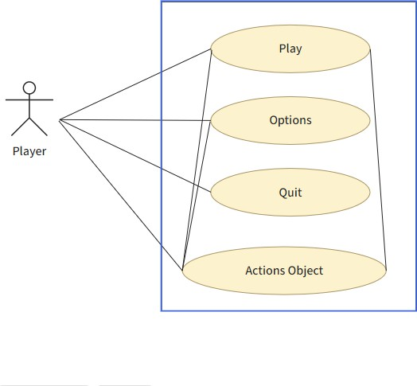
Fig 2.2: Level1forGameUX

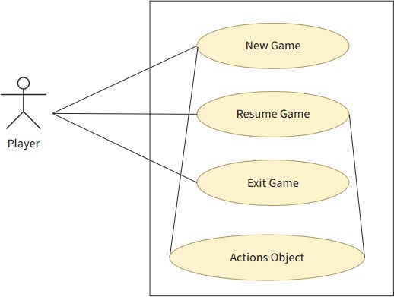

Fig2.3:LevelPlayfor GameUX

This Diagramof Level 2.1(Fig 3) leads us to the “Play” module of the use cases. These use case descriptions are given here–

Play

Usecase:PlayGame

PrimaryActors:Anyoneplayingthegame

Goalincontext: Tostartthegame
Precondition:
Systemsupportsthegameconfiguration

Thefilehasbeentriggeredtorunandthegamescreenhasappeared

Triggers:Theplayerneedstostartanew game

Scenario:

Gotothe mainmenuofthegame

Clickplaybutton’

Gameisloadedonsystem

Exception:Gamecrashed

Priority:Essential,mustbeimplemented

WhenAvailable:Firstincrement

Usecase:ResumeGame

PrimaryActors:Anyoneplayingthegame

Goalincontext:Toresume gamefrom previousplay

Precondition:

Gamewasplayedbefore

Gamesupportstohaveacheckpointtostartfrom

Triggers:Needtoresumegame

Scenario:

Gotothepausemenuofthegame

Clicktheresumebutton

Gameisloadedfromthelastcheckpoint

Exception:

Gamecrashed

Priority:Essential,mustbeimplemented

Usecase:ExitGame

PrimaryActors:Anyoneplayingthegame
Goal in context: To exit from the level Precondition: A game level is being played Triggers:Playerneeds toexitfromthegamelevel
Scenario:

Pressgamepausebutton

WhenPauseMenuappears,clickexitbutton

GameisexitedandTitlescreenappears Priority: Essential, must be implemented When Available: First increment

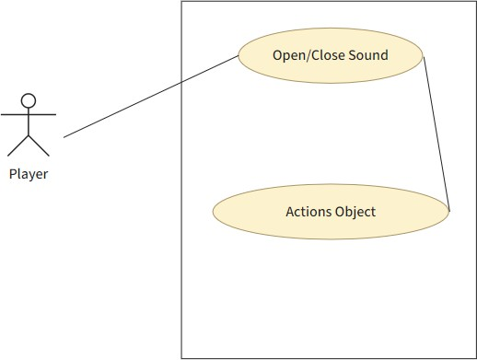

Fig2.4:LevelOptionsforGameUX

This Diagramof Level 2.2(Fig 4) connects with the “Option” module of the use cases.These use case descriptions are given here–

Options

i:Usecase:ChangeSound/MusicVolumePrimaryActors:Anyoneplayingthegame
Goal in context: To change the sound or music volume Precondition:Playerisallowedtochangevolumeofgame Triggers:Playerhasaneed tochangevolumeofthegame Scenario:

Gotothemainmenu

ClickonOptionsbutton

ClickonMusic/SoundSliderandchangethe value

MusicorSoundVolumeischanged

Exception:Systemisinmutemode,cannotincreasevolume

Priority:Expected

WhenAvailable:Secondincrement

ActivityDiagram

GotoMainMenu
ClickPlayGame
GameScene
Fig2.5:ActivityDiagramfor“NewGame”moduleof“Play”(Fig3)


GotoPause
ClickResumeGame
LastPlayedSceneLoad

Fig2.6:ActivityDiagramfor“ResumeGame”moduleof“Play”


PressPauseGame
PauseMenuAppears
ClickExitGame
GameExited
Fig2.8:ActivityDiagramfor“ExitGame”moduleof“Play”


GotoMainMenu
ClickOptions
OptionMenuAppears
ShowSoundMenu
SoundButton
Fig2.9:ActivityDiagramfor“ShowControls”moduleof“Options”


GotoMainMenu
ClickQuit
GameExited
Fig2.10:ActivityDiagramfor“Quit”module

SwimlaneDiagram

UX | BackgroundProgramming
Go to Main Menu  Click Play | LoadGameplay
Fig2.11:SwimlaneDiagramfor“NewGame”moduleof“Play”
UX
BackgroundProgramming

UX | BackgroundProgramming
Click pause Menu  Click ResumeGame | LastPlayedGamePlay

UX | BackgroundProgramming
PressPause  ClickExitGame | PauseMenuAppears  GameExited

Fig2.13:SwimlaneDiagramfor“ExitGame”moduleof“Play”

UX | BackgroundProgramming
Go to Main Menu  Click Quit | GameExited

Fig2.14:SwimlaneDiagramfor“Quit”module

DataModel
If software requirements include the need to create, extend or interface with database or if complex data structures must be constructed and manipulated, the software team may choose to create a data model as part of overall requirements modeling. Although our game has many data objects, it does not have any data storage. All the objects and their related data are handled by the game engine. So, the developers need not think about data storage. For this reason, data modelis redundant for this game project.

BehavioralModel
The Behavioral indicates how software will respond to external events or stimuli. There are two ways to show these responses. One is state diagram and the other is sequence. Usually, state diagram can be made in two ways, one iscreating a state diagram for each class and theotheris to create a state diagram for the whole system. As we don’t have any class, for this is not an object-oriented game, we have followed the later one. We used the modules of the use case scenario to create the state diagram. And to lessen complexity we have divided the state diagram into two diagrams. On the other hand, for the sequence diagram, we have created separate a sequence diagram for all the use cases when necessary.

StateDiagram
fromLevelSelect,LevelComplete,andInGameMenusinPlayLevel

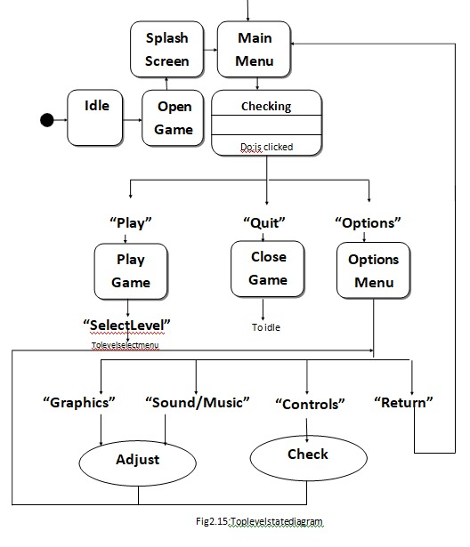

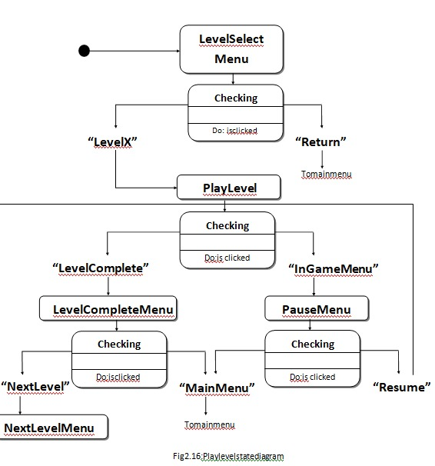

SequenceDiagram


Open game
play/mode/lev
Level1
Loaded
UX
Backend
Fig3.17:Sequencediagram(NewGame)


Open game
Clickresume
game
Checking
lookup
levelreturned
Level
Loaded
UX

Fig2.18:Sequencediagram(ResumeGame)
Backend
ActiveObject


Open game
Clickselectlevel
LevelSelect
selectlevelX
Menu
LevelX
Loaded
Backend
UX
Fig2.19:Sequencediagram(SelectLevel)


Playinggame
PressGamePause
Taking input
Clickbacktomainmenu
PauseMenu
Appears
MainMenu
Appears
Backend
UX
43|Page Fig2.20:Sequencediagram(ExitGame)


Open game
Clickoptions
Clickback toshow
controls
OptionMenu
Appears
Controls
Showed
Backend
UX

Fig2.21:Sequencediagram(ShowControl)

Opengame
UX
ActiveObject
Backend

ClickOptions

Changegraphics/ sound/ music

OptionMenu Appears

Updated

Fig2.22:Sequencediagram(ChangeGraphics/Sound/Music)


Open game
ClickScore Board
Lookupinformation
Changegraphics/
sound/music

ClickReset
ScoreBoard
Appears
Updated
ActiveObject
Backend
UX

Fig2.23:Sequencediagram(ViewandResetScore Board)

RequirementChangeManagementofOurSystem
‘The developers intend to release a complete and fully functional game that follows the guidelines mentioned in the SRS document. However, since the product will be released for multiple Android platforms (i.e., the different phones running the Android system), updates will likely be required. These updates would consist of any bug fixes that are necessary, compatibility patches for all of the current phones that support the Android System, and expansions of the content. If the players find any issues or has any comments, they would be able to contact the developers through the official support email address which is ghostInTheTown_support@gmail.com.
Formanagingthechanges,wearereleasingversionsofthisdocument.Thisoneisversion2.1.

BugsandGlitches
Theplayerswouldbeabletocontactthedevelopersthroughthesupportemailsystem.Thisis wheretheywouldpresentanybugsorglitchestheyhavedetectedandiftheyhaveanybeliefs thatthegameisnotfunctioningproperly.Generalconcernsorcommentswouldalsoneedto be submitted here.
Wewillcheckthisemailregularlyinordertorespondtoanytimesensitiveinformation.

Patches
As the Android system is updated and new phones come out, the game would also need to be updated. Developers would constantly be making changes in order to keep up with any compatibility issues that may arise. These changes and any others that may be fixing bugs or glitches would be released throughthese patches

